MUJTABA SHAHID FAIZI

BSCS-5A

131818

LAB 2 OF AP

Introduction: A new café in Islamabad wants to establish a niche by providing an online delivery and pick-up information system for their customers

Approach & Design: I have used java to implement a single class and added functions to calculate and display time, bill, orders etc. of users according to the opening and closing times of the café.

How to run: The menu list is displayed and the user has to select the food item and its quantity.

It will display the bill, time for order to take (factoring in all the previous orders) and then the next order will be waiting to be made.

Analysis:

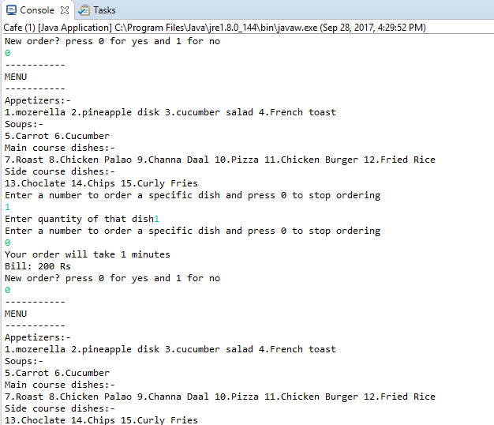

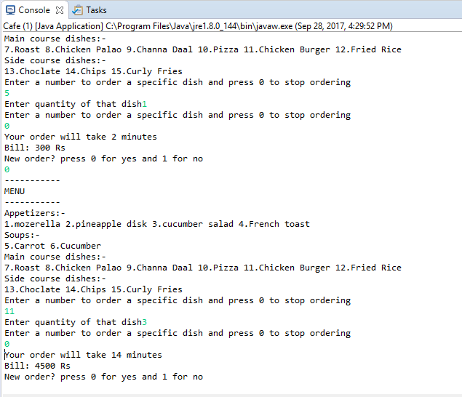

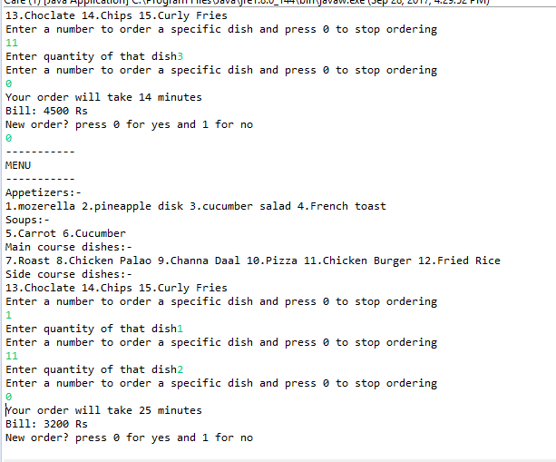

Github Link: <https://github.com/mujtaba-faizi/e-Cafe>

